Experiment 1 — Installation of Hypervisors and initiation of VMs with image file.

Install and configure an open-source hypervisor and create/instantiate a Virtual Machine (VM) using an existing image file. Demonstrate the successful installation and execution of the VM.

Tasks
- Install an open-source hypervisor such as Oracle VirtualBox
- Obtain a suitable VM image/ISO file.
- Create a new VM using the hypervisor.
- Configure the VM's CPU, RAM, storage, and network.
- Attach the image/ISO file to the VM.
- Start and boot the VM.
- Complete the guest OS installation, if required.
- Verify that the VM is running successfully.
- Installing the required build tools and Linux kernel headers using the below commands:
sudo apt update
sudo apt install -y build-essential linux-headers-$(uname -r)
- Record the configuration and capture relevant screenshots.

- Installing and opening Oracle Virtual Machine
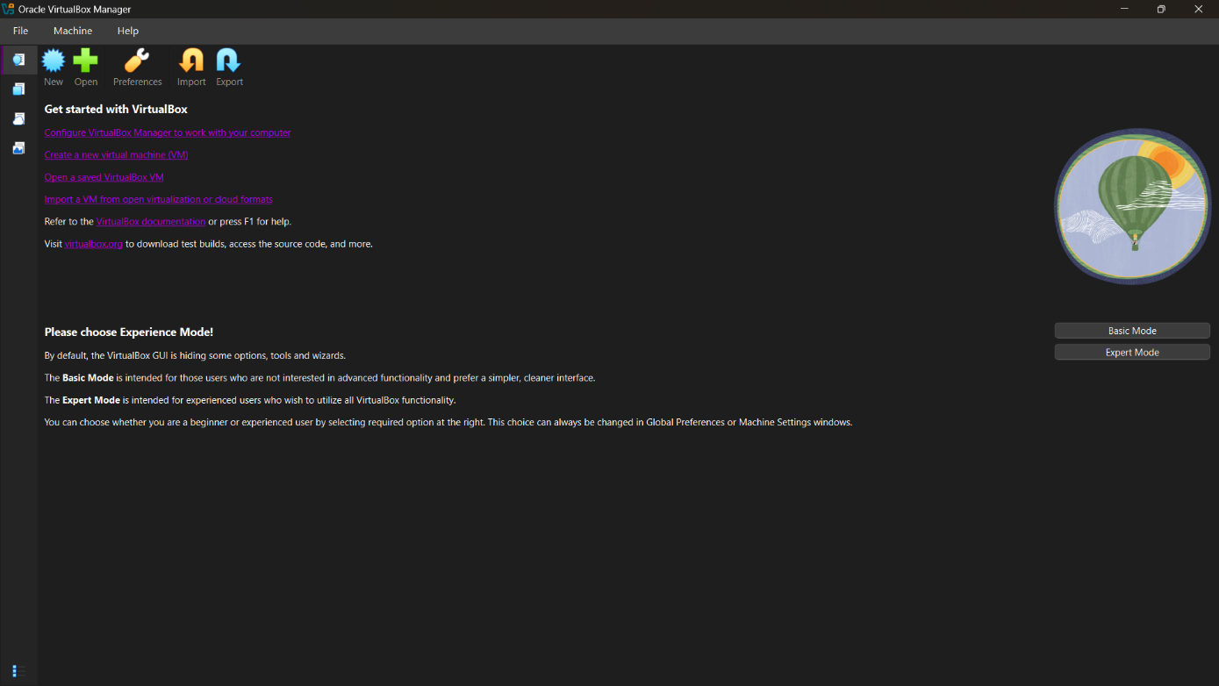

- Uploading ISO file for OS installation in VM
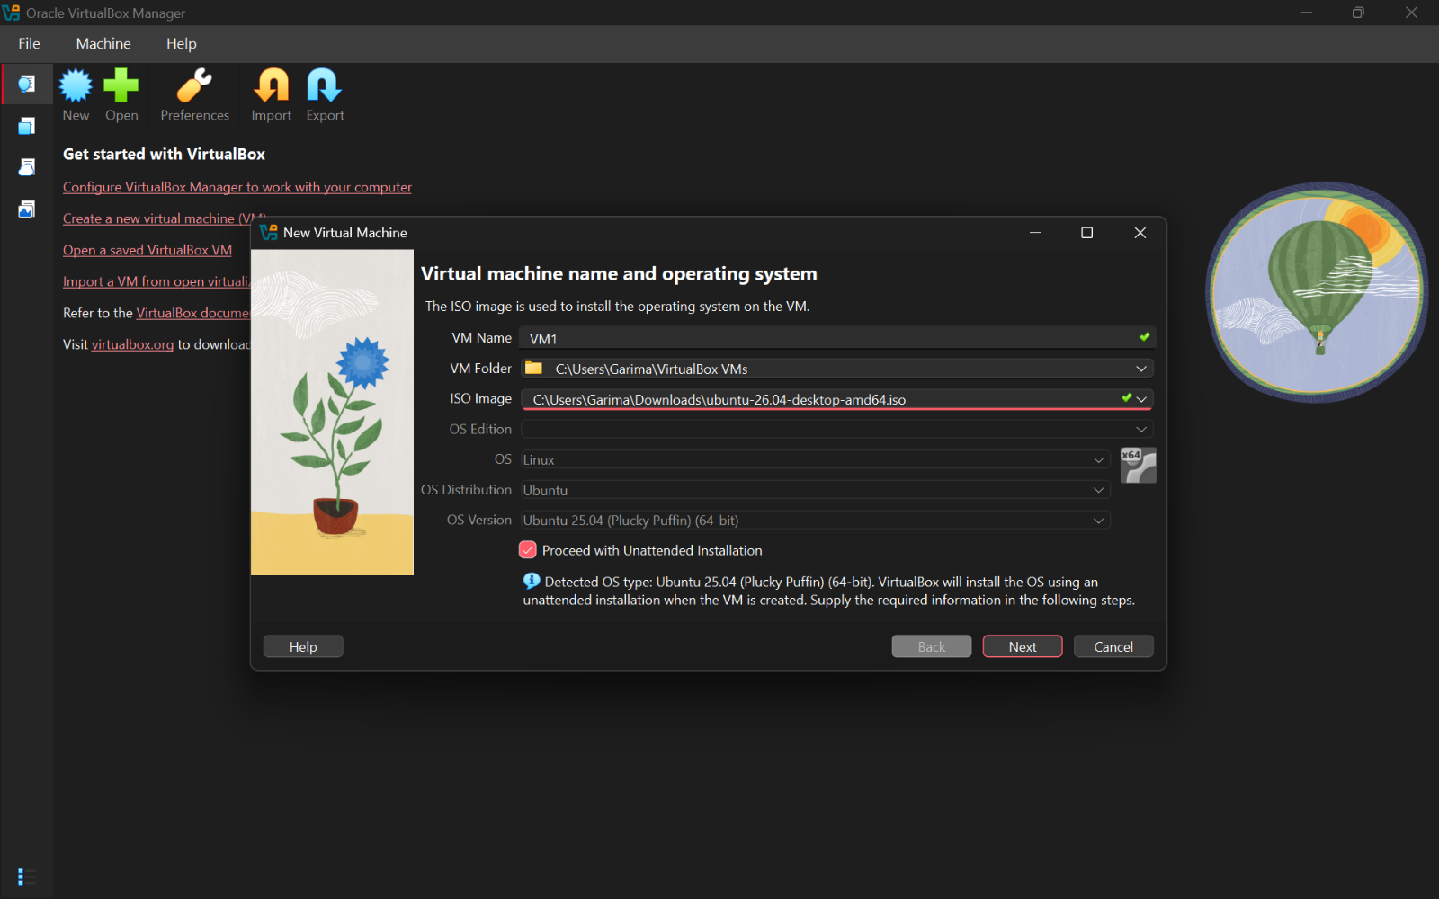

- Hardware setup for VM
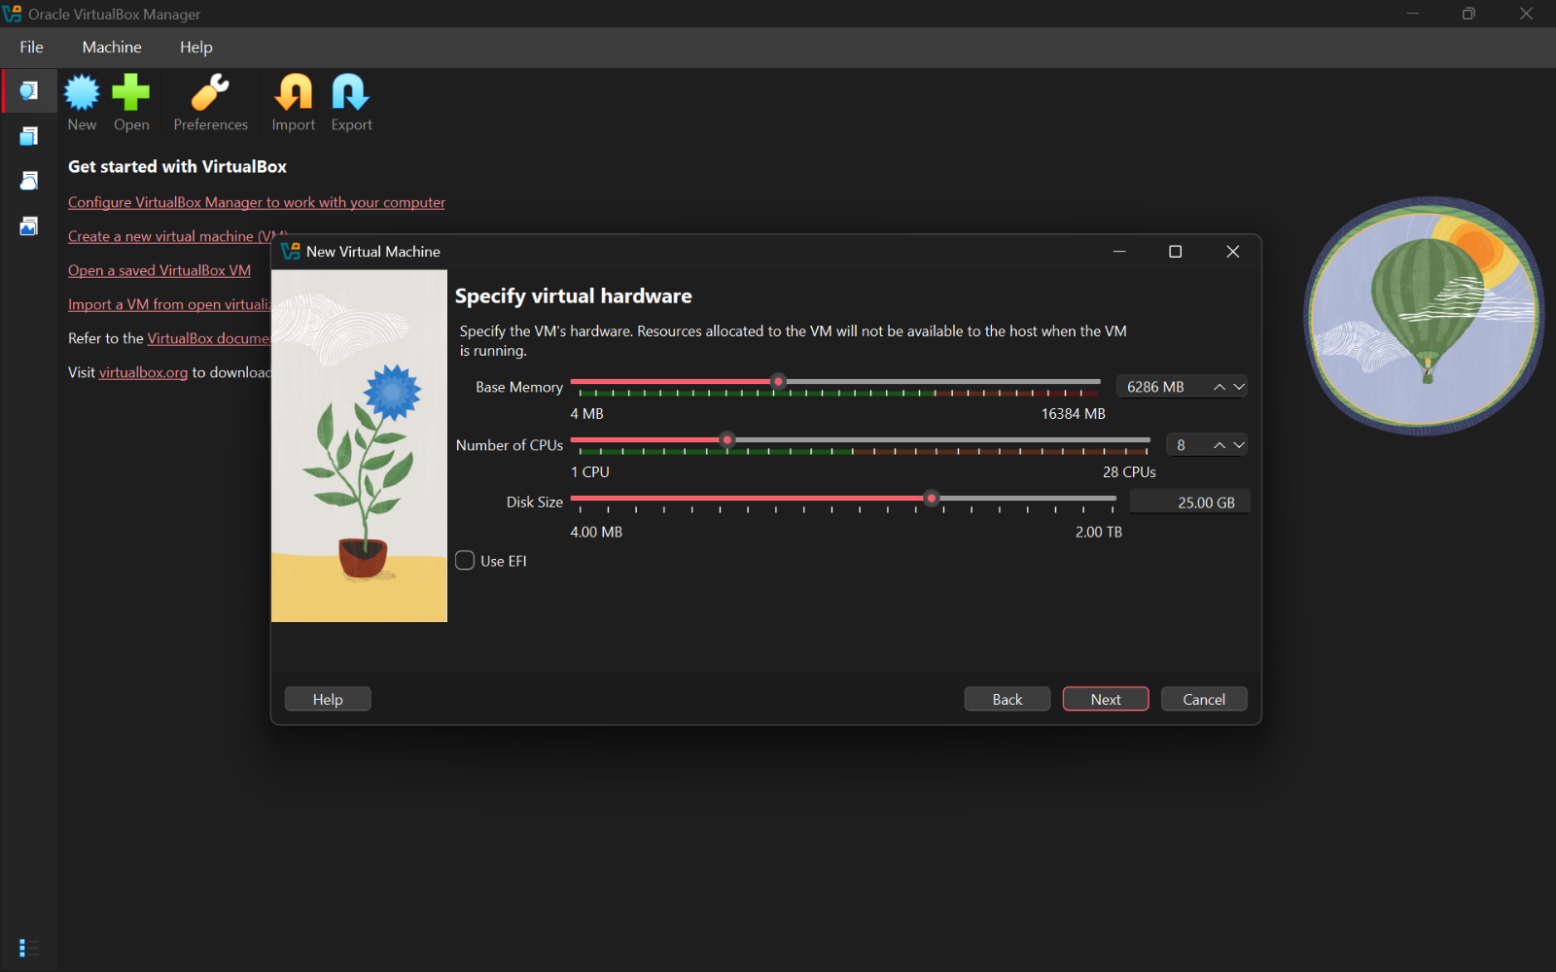

- Virtual Machine Configuration
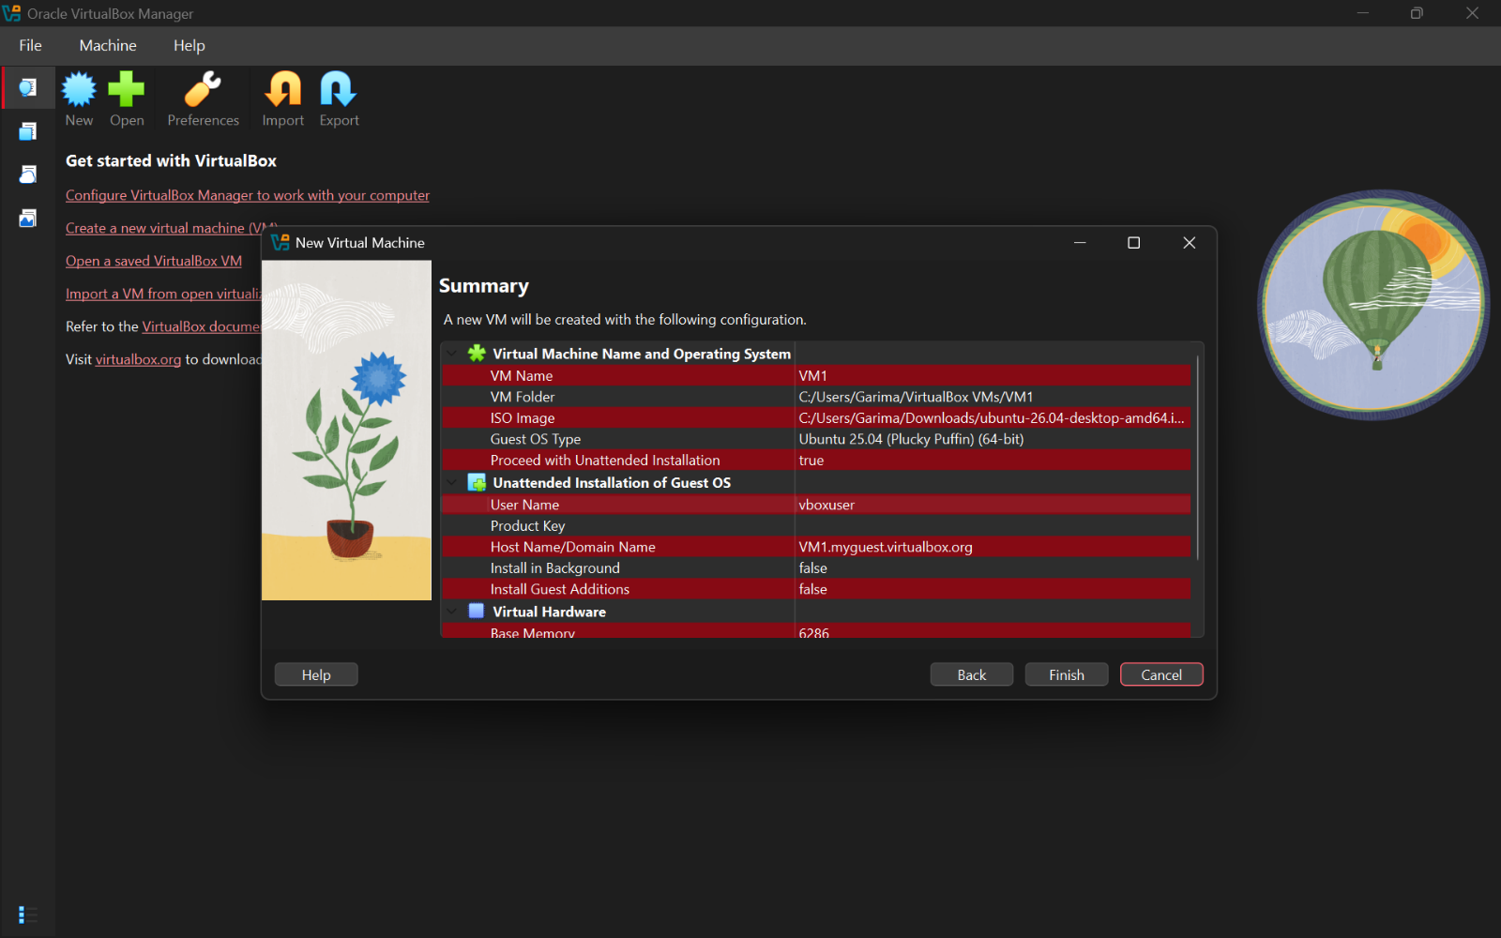

- Ubuntu installation in VM
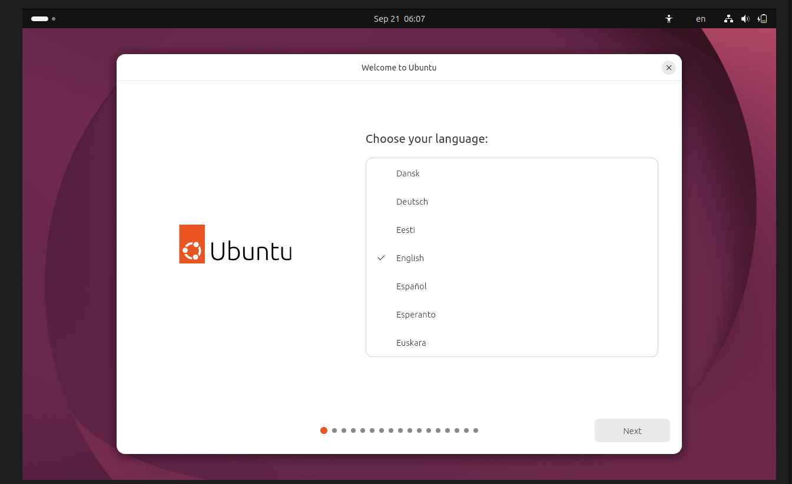

- Ubuntu Home Screen
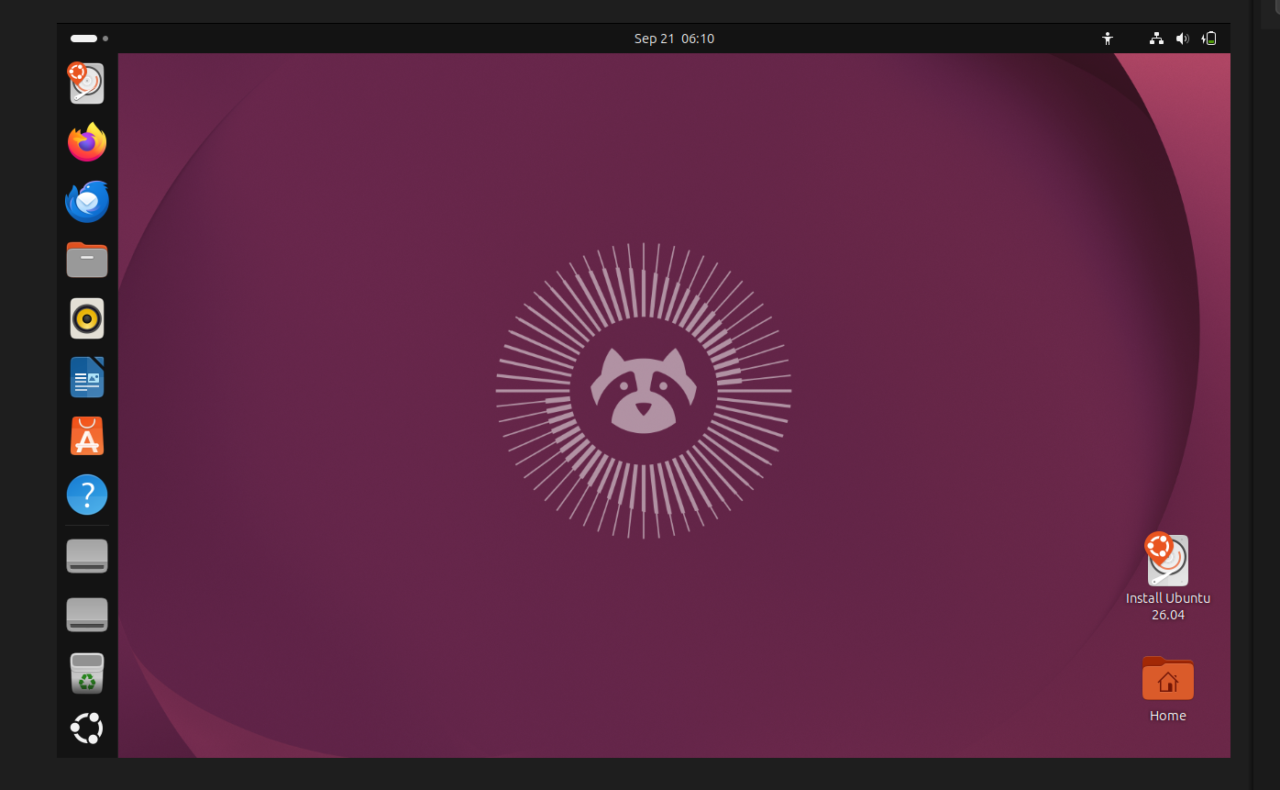

- Install build tools & kernel headers using following command:
- sudo apt update
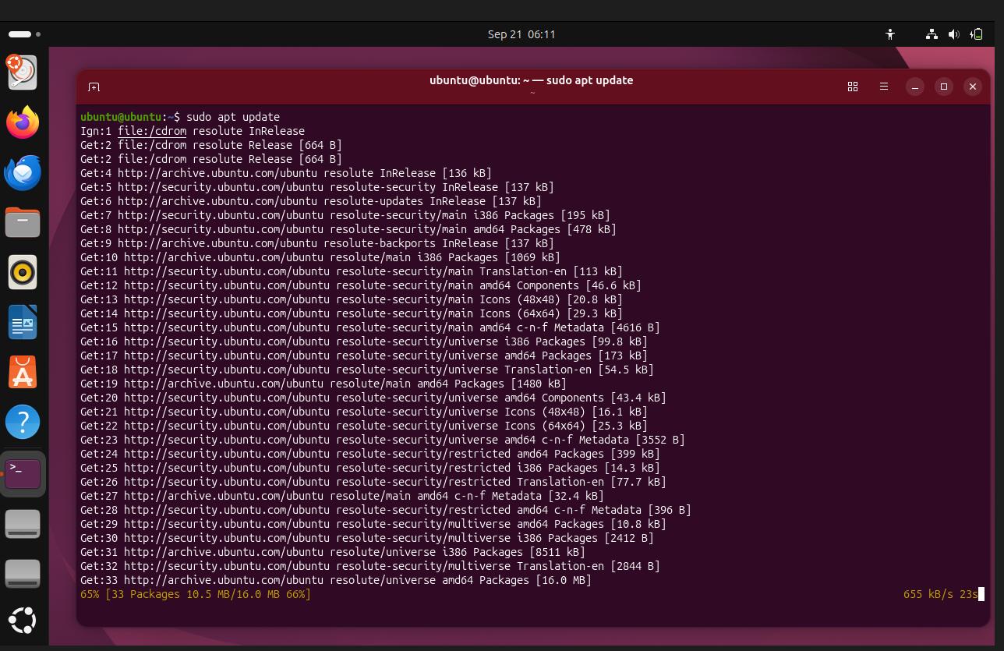

- sudo apt install -y build-essential linux-headers-$(uname -r)
